**DBMS LAB 7**

**PROGRAM 7: BOOK DEALER DATABASE**

The following tables are maintained by a book dealer:

AUTHOR(author-id: int, name: String, city: String, country: String)  
PUBLISHER(publisher-id: int, name: String, city: String, country: String)  
CATALOG (book-id: int, title: String, author-id: int, publisher-id: int, category-id: int, year: int, price: int)  
CATEGORY(category-id: int, description: String)  
ORDER-DETAILS(order-no: int, book-id: int, quantity: int)

i. Create the above tables by properly specifying the primary keys and the foreign keys.

**-- create a database**

**create database BOOK_DEALER;**

**use BOOK_DEALER;**

**-- create a table**

**CREATE TABLE AUTHOR**

**(**

**AUTHORID INT,**

**NAME VARCHAR (15),**

**CITY VARCHAR (15),**

**COUNTRY VARCHAR (15),**

**PRIMARY KEY(AUTHORID)**

**);**

**desc AUTHOR;**

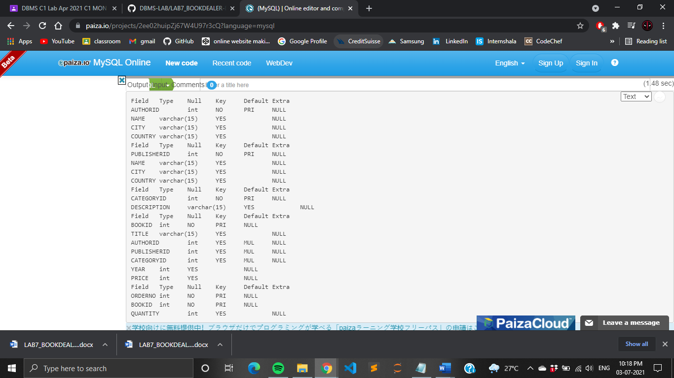

**-- create a table**

**CREATE TABLE PUBLISHER**

**(**

**PUBLISHERID INT,**

**NAME VARCHAR(15),**

**CITY VARCHAR(15),**

**COUNTRY VARCHAR(15),**

**PRIMARY KEY(PUBLISHERID)**

**);**

**desc PUBLISHER;**



**-- create a table**

**CREATE TABLE CATEGORY**

**(**

**CATEGORYID INT,**

**DESCRIPTION VARCHAR(15),**

**PRIMARY KEY(CATEGORYID)**

**);**

**desc CATEGORY;**



**-- create a table**

**CREATE TABLE CATALOG**

**(**

**BOOKID INT,**

**TITLE VARCHAR(15),**

**AUTHORID INT,**

**PUBLISHERID INT,**

**CATEGORYID INT,**

**YEAR INT,**

**PRICE INT,**

**PRIMARY KEY(BOOKID),**

**FOREIGN KEY(AUTHORID) REFERENCES AUTHOR(AUTHORID),**

**FOREIGN KEY(PUBLISHERID) REFERENCES PUBLISHER(PUBLISHERID),**

**FOREIGN KEY(CATEGORYID) REFERENCES CATEGORY(CATEGORYID)**

**);**

**desc CATALOG;**



**-- create a table**

**CREATE TABLE ORDER_DETAILS**

**(**

**ORDERNO INT,**

**BOOKID INT,**

**QUANTITY INT,**

**PRIMARY KEY(ORDERNO,BOOKID),**

**FOREIGN KEY(BOOKID) REFERENCES CATALOG(BOOKID)**

**);**

**desc ORDER_DETAILS;**



ii. Enter at least five tuples for each relation.

**-- insert values into AUTHOR**

**INSERT INTO AUTHOR VALUES**

**(101, 'ABC', 'DELHI','NDIA'),**

**(102,'TONY','HAYHOOD','USA'),**

**(103,'GHI','PATNA','INDIA'),**

**(104,'JKL','BELM','SRILANKA'),**

**(105,'MND','BANGALORE','INDIA');**

**SELECT * FROM AUTHOR;**

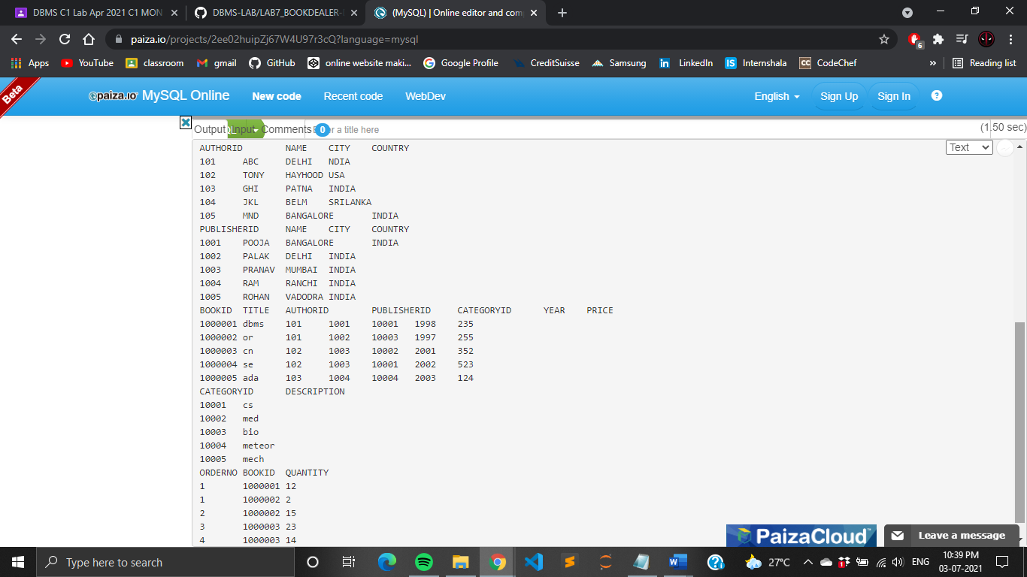

**-- insert values into PUBLISHER**

**INSERT INTO PUBLISHER VALUES**

**(1001, 'POOJA','BANGALORE', 'INDIA'),**

**(1002, 'PALAK','DELHI' ,'INDIA'),**

**(1003, 'PRANAV', 'MUMBAI', 'INDIA'),**

**(1004, 'RAM', 'RANCHI', 'INDIA'),**

**(1005, 'ROHAN', 'VADODRA', 'INDIA');**

**SELECT * FROM PUBLISHER;**



**-- insert values into CATALOG**

**INSERT INTO CATALOG VALUES**

**(1000001, 'dbms', 101, 1001, 10001, 1998, 235),**

**(1000002, 'or', 101, 1002, 10003, 1997, 255),**

**(1000003, 'cn', 102, 1003, 10002, 2001, 352),**

**(1000004, 'se', 102, 1003, 10001, 2002, 523),**

**(1000005, 'ada', 103, 1004, 10004, 2003, 124);**

**SELECT * FROM CATALOG;**



**-- insert values into CATEGORY**

**INSERT INTO CATEGORY VALUES**

**(10001, 'cs'),**

**(10002, 'med'),**

**(10003, 'bio'),**

**(10004, 'meteor'),**

**(10005, 'mech');**

**SELECT * FROM CATEGORY;**



**-- insert values into ORDER_DETAILS**

**INSERT INTO ORDER_DETAILS VALUES**

**(1, 1000001, 12),**

**(1, 1000002, 2),**

**(2, 1000002, 15),**

**(3, 1000003, 23),**

**(4, 1000003, 14),**

**(5, 1000005, 7);**

**SELECT * FROM ORDER_DETAILS;**

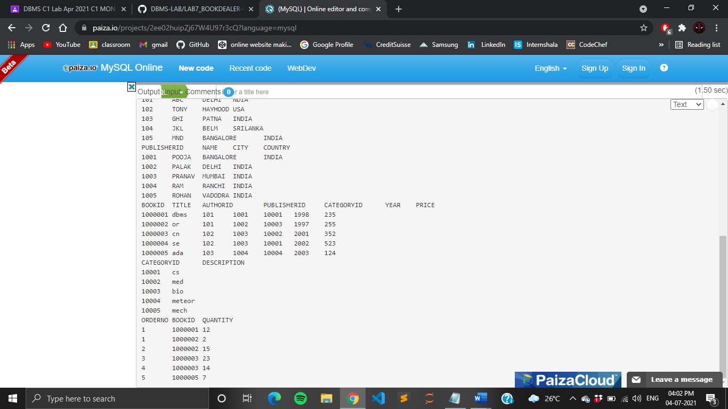

iii. Give the details of the authors who have 2 or more books in the catalog and the price of the books in the catalog and the year of publication is after 2000.

**SELECT * FROM AUTHOR A WHERE A.AUTHORID IN (SELECT C.AUTHORID FROM CATALOG C WHERE YEAR>2000 AND C.PRICE > (SELECT AVG (PRICE) FROM CATALOG) GROUP BY C.AUTHORID HAVING COUNT(AUTHORID)>=2);**

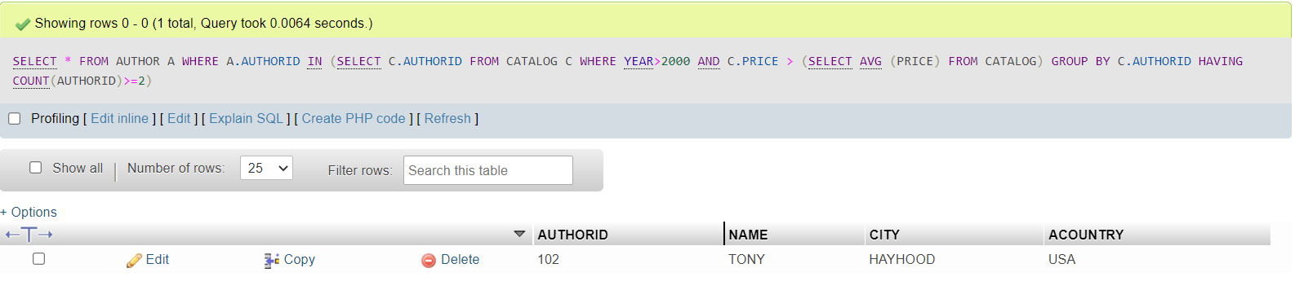

iv. Find the author of the book which has maximum sales.

**SELECT NAME FROM AUTHOR A,CATALOG C WHERE A.AUTHORID=C.AUTHORID AND BOOKID IN**

**(SELECT BOOKID FROM ORDER_DETAILS WHERE QUANTITY= (SELECT MAX(QUANTITY) FROM ORDER_DETAILS));**

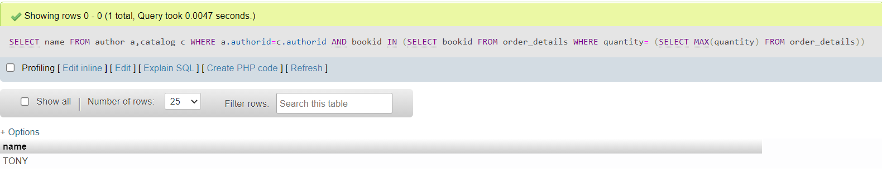

v. Demonstrate how you increase the price of books published by a specific publisher by 10%.

**UPDATE CATALOG SET PRICE = PRICE*1.1 WHERE PUBLISHERID IN ( SELECT PUBLISHERID FROM PUBLISHER WHERE NAME= 'POOJA');**

